# CS 255 System Design Document Template

This template lays out all the different sections that you need to complete for Project Two. Each section has guidance to prompt your thinking. You will need to continually reference the interview transcript as you work to make sure that you are addressing your client’s needs. There is no required length for the final document. Instead the goal is to complete each section based on what your client’s needs are. Remove this note when you are finished, and replace all bracketed text with the relevant information.

## UML Diagrams

### UML Use Case Diagram

### UML Activity Diagrams

1. User login

2. Purchase a driver package

### UML Sequence Diagram

### UML Class Diagram

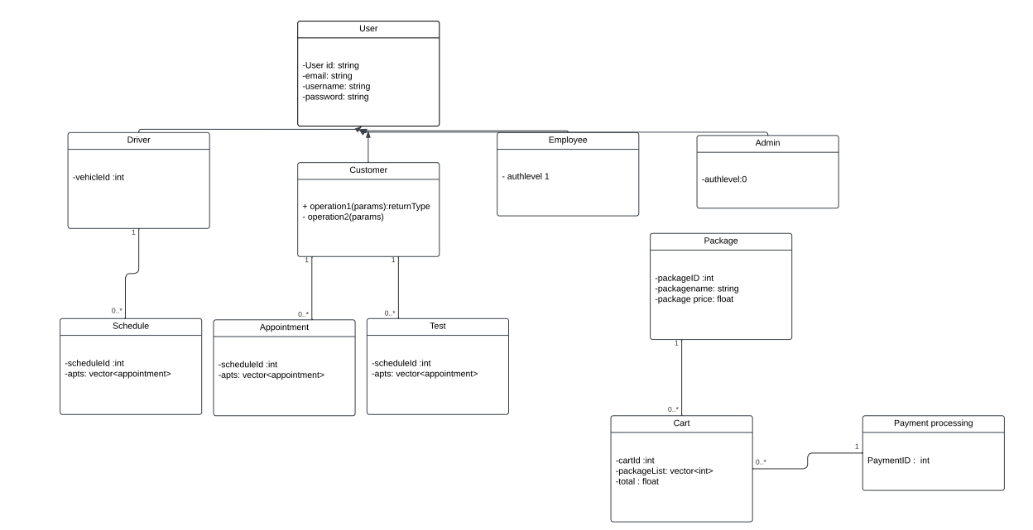

## Technical Requirements

**Hardware Requirements:**

* A dedicated server.
* A reliable internet connection.
* Sufficient storage capacity for database and website data.
* A computer or mobile device for user access to the website.
* A firewall to protect website ports.

**Software Requirements:**

* Windows Server/cloud for its stability.
* SQL Server for the database.
* Backup software for both the website and database.
* A web server.
* Security software to prevent malware threats.
* Encryption